**Creating Table and Stored Procedures**

We will be using a DB table to store all the records of employees.

Open SQL Server and use the following script to create tblEmployee table.

Create table tblEmployee(

EmployeeId int IDENTITY(1,1) NOT NULL,

Name varchar(20) NOT NULL,

City varchar(20) NOT NULL,

Department varchar(20) NOT NULL,

Gender varchar(6) NOT NULL

)

Now, we will create stored procedures to add, delete, update, and get employee data.

### To insert an Employee Record

Create procedure spAddEmployee

(

@Name VARCHAR(20),

@City VARCHAR(20),

@Department VARCHAR(20),

@Gender VARCHAR(6)

)

as

Begin

Insert into tblEmployee (Name,City,Department, Gender)

Values (@Name,@City,@Department, @Gender)

End

### To update an Employee Record

Create procedure spUpdateEmployee

(

@EmpId INTEGER ,

@Name VARCHAR(20),

@City VARCHAR(20),

@Department VARCHAR(20),

@Gender VARCHAR(6)

)

as

begin

Update tblEmployee

set Name=@Name,

City=@City,

Department=@Department,

Gender=@Gender

where EmployeeId=@EmpId

End

### For deleting an Employee Record

Create procedure spDeleteEmployee

(

@EmpId int

)

as

begin

Delete from tblEmployee where EmployeeId=@EmpId

End

### Fetch all Employee Records

Create procedure spGetAllEmployees

as

Begin

select *

from tblEmployee

order by EmployeeId

End

Now, our Database part has been completed. So, we will proceed to create the MVC application using Visual Studio.

## Create MVC Web Application

**Step 1:** Open Visual Studio and select File >> New >> Project.

**Step 2:** After selecting the project, a “New Project” dialog will open. Select .NET Core inside Visual C# menu from the left panel.  
Then, select “ASP.NET Core Web Application” from available project types. Put the name of the project as MVCDemoApp and press OK.

**Step 3:** After clicking on OK, a new dialog will open asking to select the project template. You can observe two drop-down menus at the top left of the template window. Select “.NET Core” and “ASP.NET Core 8.0” from these dropdowns. Then, select “Web application(Model-View-Controller)” template and press OK.

**Step 4:** Now our project will open. You can observe that we have Models, Views and Controllers folders already created. We will be adding our files to these folders only.

## Adding the Controller to the Application

Right click on Controllers folder and select Add >> New Item

**Step 2:** An “Add New Item” dialog box will open. Select Web from the left panel, then select “MVC Controller Class” from templates panel, and put the name as EmployeeController.cs. Press OK.

Now our EmployeeController has been created. We will put all our business logic in this controller.

## Adding the Model to the Application

Right click on Models folder and select Add >> Class. Name your class Employee.cs. This class will contain our Employee model properties.

Add one more class file to Models folder. Name it as EmployeeDataAccessLayer.cs . This class will contain our Database related operations.

Open Employee.cs and put the following code in it. Since we are adding the required validators to the fields of Employee class, so we need to use System.ComponentModel.DataAnnotations at the top.

using System;

using System.Collections.Generic;

using System.ComponentModel.DataAnnotations;

using System.Linq;

using System.Threading.Tasks;

namespace MVCDemoApp.Models

{

public class Employee

{

public int ID { get; set; }

[Required]

public string Name { get; set; }

[Required]

public string Gender { get; set; }

[Required]

public string Department { get; set; }

[Required]

public string City { get; set; }

}

}

Open EmployeeDataAccessLayer.cs and put the following code to handle database operations. Make sure to put your connection string.

using System;

using System.Collections.Generic;

using System.Data;

using MicroSoft.Data.SqlClient;

using System.Linq;

using System.Threading.Tasks;

namespace MVCDemoApp.Models

{

public class EmployeeDataAccessLayer

{

string connectionString = "Server= LENOVO-MILAN\\MSSQLSERVER01; Database = webapp; Trusted_Connection = True; TrustServerCertificate=True";

//To View all employees details

public IEnumerable<Employee> GetAllEmployees()

{

List<Employee> lstemployee = new List<Employee>();

using (SqlConnection con = new SqlConnection(connectionString))

{

SqlCommand cmd = new SqlCommand("spGetAllEmployees", con);

cmd.CommandType = CommandType.StoredProcedure;

con.Open();

SqlDataReader rdr = cmd.ExecuteReader();

while (rdr.Read())

{

Employee employee = new Employee();

employee.ID = Convert.ToInt32(rdr["EmployeeID"]);

employee.Name = rdr["Name"].ToString();

employee.Gender = rdr["Gender"].ToString();

employee.Department = rdr["Department"].ToString();

employee.City = rdr["City"].ToString();

lstemployee.Add(employee);

}

con.Close();

}

return lstemployee;

}

//To Add new employee record

public void AddEmployee(Employee employee)

{

using (SqlConnection con = new SqlConnection(connectionString))

{

SqlCommand cmd = new SqlCommand("spAddEmployee", con);

cmd.CommandType = CommandType.StoredProcedure;

cmd.Parameters.AddWithValue("@Name", employee.Name);

cmd.Parameters.AddWithValue("@Gender", employee.Gender);

cmd.Parameters.AddWithValue("@Department", employee.Department);

cmd.Parameters.AddWithValue("@City", employee.City);

con.Open();

cmd.ExecuteNonQuery();

con.Close();

}

}

//To Update the records of a particluar employee

public void UpdateEmployee(Employee employee)

{

using (SqlConnection con = new SqlConnection(connectionString))

{

SqlCommand cmd = new SqlCommand("spUpdateEmployee", con);

cmd.CommandType = CommandType.StoredProcedure;

cmd.Parameters.AddWithValue("@EmpId", employee.ID);

cmd.Parameters.AddWithValue("@Name", employee.Name);

cmd.Parameters.AddWithValue("@Gender", employee.Gender);

cmd.Parameters.AddWithValue("@Department", employee.Department);

cmd.Parameters.AddWithValue("@City", employee.City);

con.Open();

cmd.ExecuteNonQuery();

con.Close();

}

}

//Get the details of a particular employee

public Employee GetEmployeeData(int? id)

{

Employee employee = new Employee();

using (SqlConnection con = new SqlConnection(connectionString))

{

string sqlQuery = "SELECT * FROM tblEmployee WHERE EmployeeID= " + id;

SqlCommand cmd = new SqlCommand(sqlQuery, con);

con.Open();

SqlDataReader rdr = cmd.ExecuteReader();

while (rdr.Read())

{

employee.ID = Convert.ToInt32(rdr["EmployeeID"]);

employee.Name = rdr["Name"].ToString();

employee.Gender = rdr["Gender"].ToString();

employee.Department = rdr["Department"].ToString();

employee.City = rdr["City"].ToString();

}

}

return employee;

}

//To Delete the record on a particular employee

public void DeleteEmployee(int? id)

{

using (SqlConnection con = new SqlConnection(connectionString))

{

SqlCommand cmd = new SqlCommand("spDeleteEmployee", con);

cmd.CommandType = CommandType.StoredProcedure;

cmd.Parameters.AddWithValue("@EmpId", id);

con.Open();

cmd.ExecuteNonQuery();

con.Close();

}

}

}

}

Now, we will proceed to create our Views.

## Adding Views to the Application

To add views for our controller class, we need to create a folder inside Views folder with the same name as our controller and then add our views to that folder.

Right-click on the Views folder, and then Add >> New Folder and name the folder as Employee.

Now Right click on the Views/Employee folder, and then select Add >> New Item.

An “Add New Item” dialog box will open. Select Web from the left panel, then select “MVC View Page” from templates panel, and put the name as Index.cshtml. Press OK.

Thus we have created our first view. Similarly add 4 more views in Views/Employee folder, Create.cshtml, Delete.cshtml, Details.cshtml, and Edit.cshtml.

Since our Views has been created, we will put codes in View and Controller for performing CRUD operations.

## Create View

This view will be used to Add new employee data to the database.

Open Create.cshtml and put following code into it.

@model MVCDemoApp.Models.Employee

@{

ViewData["Title"] = "Create";

}

<h2>Create</h2>

<h4>Employees</h4>

<hr />

<div class="row">

<div class="col-md-4">

<form asp-action="Create">

<div asp-validation-summary="ModelOnly" class="text-danger"></div>

<div class="form-group">

<label asp-for="Name" class="control-label"></label>

<input asp-for="Name" class="form-control" />

<span asp-validation-for="Name" class="text-danger"></span>

</div>

<div class="form-group">

<label asp-for="Gender" class="control-label"></label>

<select asp-for="Gender" class="form-control">

<option value="">-- Select Gender --</option>

<option value="Male">Male</option>

<option value="Female">Female</option>

</select>

<span asp-validation-for="Gender" class="text-danger"></span>

</div>

<div class="form-group">

<label asp-for="Department" class="control-label"></label>

<input asp-for="Department" class="form-control" />

<span asp-validation-for="Department" class="text-danger"></span>

</div>

<div class="form-group">

<label asp-for="City" class="control-label"></label>

<input asp-for="City" class="form-control" />

<span asp-validation-for="City" class="text-danger"></span>

</div>

<div class="form-group">

<input type="submit" value="Create" class="btn btn-default" />

</div>

</form>

</div>

</div>

<div>

<a asp-action="Index">Back to List</a>

</div>

@section Scripts {

@{await Html.RenderPartialAsync("_ValidationScriptsPartial");}

}

To handle database operations, we will create an object of EmployeeDataAccessLayer class inside the EmployeeController class.

public class EmployeeController : Controller

{

EmployeeDataAccessLayer objemployee = new EmployeeDataAccessLayer();

// GET: /<controller>/

public IActionResult Index()

{

}

}

To handle the business logic of create, open EmployeeController.cs and put following code into it.

[HttpGet]

public IActionResult Create()

{

return View();

}

[HttpPost]

[ValidateAntiForgeryToken]

public IActionResult Create([Bind] Employee employee)

{

if (ModelState.IsValid)

{

objemployee.AddEmployee(employee);

return RedirectToAction("Index");

}

return View(employee);

}

## Index View

This view will be displaying all the employee records present in the database. Additionally, we will also be providing action methods Edit, Details and Delete on each record.

Open Index.cshtml and put following code in it

@model IEnumerable<MVCDemoApp.Models.Employee>

@{

ViewData["Title"] = "Index";

}

<h2>Index</h2>

<p>

<a asp-action="Create">Create New</a>

</p>

<table class="table">

<thead>

<tr>

<th>

@Html.DisplayNameFor(model => model.Name)

</th>

<th>

@Html.DisplayNameFor(model => model.Gender)

</th>

<th>

@Html.DisplayNameFor(model => model.Department)

</th>

<th>

@Html.DisplayNameFor(model => model.City)

</th>

<th></th>

</tr>

</thead>

<tbody>

@foreach (var item in Model)

{

<tr>

<td>

@Html.DisplayFor(modelItem => item.Name)

</td>

<td>

@Html.DisplayFor(modelItem => item.Gender)

</td>

<td>

@Html.DisplayFor(modelItem => item.Department)

</td>

<td>

@Html.DisplayFor(modelItem => item.City)

</td>

<td>

<a asp-action="Edit" asp-route-id="@item.ID">Edit</a> |

<a asp-action="Details" asp-route-id="@item.ID">Details</a> |

<a asp-action="Delete" asp-route-id="@item.ID">Delete</a>

</td>

</tr>

}

</tbody>

</table>

To handle the business logic of Index view, open EmployeeController.cs and add following code in Index method.

public IActionResult Index()

{

List<Employee> lstEmployee = new List<Employee>();

lstEmployee = objemployee.GetAllEmployees().ToList();

return View(lstEmployee);

}

## Edit View

This view will enable us to edit an existing employee data.

Open Edit.cshtml and put following code into it.

@model MVCDemoApp.Models.Employee

@{

ViewData["Title"] = "Edit";

}

<h2>Edit</h2>

<h4>Employees</h4>

<hr />

<div class="row">

<div class="col-md-4">

<form asp-action="Edit">

<div asp-validation-summary="ModelOnly" class="text-danger"></div>

<input type="hidden" asp-for="ID" />

<div class="form-group">

<label asp-for="Name" class="control-label"></label>

<input asp-for="Name" class="form-control" />

<span asp-validation-for="Name" class="text-danger"></span>

</div>

<div class="form-group">

<label asp-for="Gender" class="control-label"></label>

<select asp-for="Gender" class="form-control">

<option value="">-- Select Gender --</option>

<option value="Male">Male</option>

<option value="Female">Female</option>

</select>

<span asp-validation-for="Gender" class="text-danger"></span>

</div>

<div class="form-group">

<label asp-for="Department" class="control-label"></label>

<input asp-for="Department" class="form-control" />

<span asp-validation-for="Department" class="text-danger"></span>

</div>

<div class="form-group">

<label asp-for="City" class="control-label"></label>

<input asp-for="City" class="form-control" />

<span asp-validation-for="City" class="text-danger"></span>

</div>

<div class="form-group">

<input type="submit" value="Save" class="btn btn-default" />

</div>

</form>

</div>

</div>

<div>

<a asp-action="Index">Back to List</a>

</div>

@section Scripts {

@{await Html.RenderPartialAsync("_ValidationScriptsPartial");}

}

To handle the business logic of Edit view, open EmployeeController.cs and add following code to it.

[HttpGet]

public IActionResult Edit(int? id)

{

if (id == null)

{

return NotFound();

}

Employee employee = objemployee.GetEmployeeData(id);

if (employee == null)

{

return NotFound();

}

return View(employee);

}

[HttpPost]

[ValidateAntiForgeryToken]

public IActionResult Edit(int id, [Bind]Employee employee)

{

if (id != employee.ID)

{

return NotFound();

}

if (ModelState.IsValid)

{

objemployee.UpdateEmployee(employee);

return RedirectToAction("Index");

}

return View(employee);

}

As you can observe that we have two Edit action methods, one for HttpGet and another for HttpPost.The HttpGet Edit action method will fetch the employee data and populates the fields of edit view. Once the user clicks on Save button after editing the record, a Post request will be generated which is handled by HttpPost Edit action method.

## Details View

This view will display the details of a particular employee.

Open Details.cshtml and put following code into it.

@model MVCDemoApp.Models.Employee

@{

ViewData["Title"] = "Details";

}

<h2>Details</h2>

<div>

<h4>Employees</h4>

<hr />

<dl class="dl-horizontal">

<dt>

@Html.DisplayNameFor(model => model.Name)

</dt>

<dd>

@Html.DisplayFor(model => model.Name)

</dd>

<dt>

@Html.DisplayNameFor(model => model.Gender)

</dt>

<dd>

@Html.DisplayFor(model => model.Gender)

</dd>

<dt>

@Html.DisplayNameFor(model => model.Department)

</dt>

<dd>

@Html.DisplayFor(model => model.Department)

</dd>

<dt>

@Html.DisplayNameFor(model => model.City)

</dt>

<dd>

@Html.DisplayFor(model => model.City)

</dd>

</dl>

</div>

<div>

<a asp-action="Edit" asp-route-id="@Model.ID">Edit</a> |

<a asp-action="Index">Back to List</a>

</div>

To handle the business logic of Details view,open EmployeeController.cs and add following code to it.

[HttpGet]

public IActionResult Details(int? id)

{

if (id == null)

{

return NotFound();

}

Employee employee = objemployee.GetEmployeeData(id);

if (employee == null)

{

return NotFound();

}

return View(employee);

}

## Delete View

This view will help us to remove employee data .

Open Delete.cshtml and put following code into it.

@model MVCDemoApp.Models.Employee

@{

ViewData["Title"] = "Delete";

}

<h2>Delete</h2>

<h3>Are you sure you want to delete this?</h3>

<div>

<h4>Employees</h4>

<hr />

<dl class="dl-horizontal">

<dt>

@Html.DisplayNameFor(model => model.Name)

</dt>

<dd>

@Html.DisplayFor(model => model.Name)

</dd>

<dt>

@Html.DisplayNameFor(model => model.Gender)

</dt>

<dd>

@Html.DisplayFor(model => model.Gender)

</dd>

<dt>

@Html.DisplayNameFor(model => model.Department)

</dt>

<dd>

@Html.DisplayFor(model => model.Department)

</dd>

<dt>

@Html.DisplayNameFor(model => model.City)

</dt>

<dd>

@Html.DisplayFor(model => model.City)

</dd>

</dl>

<form asp-action="Delete">

<input type="hidden" asp-for="ID" />

<input type="submit" value="Delete" class="btn btn-default" /> |

<a asp-action="Index">Back to List</a>

</form>

</div>

To handle the business logic of Delete view, open EmployeeController.cs and add following code to it.

[HttpGet]

public IActionResult Delete(int? id)

{

if (id == null)

{

return NotFound();

}

Employee employee = objemployee.GetEmployeeData(id);

if (employee == null)

{

return NotFound();

}

return View(employee);

}

[HttpPost, ActionName("Delete")]

[ValidateAntiForgeryToken]

public IActionResult DeleteConfirmed(int? id)

{

objemployee.DeleteEmployee(id);

return RedirectToAction("Index");

}

To complete Delete operation we need two Delete methods accepting same parameter (Employee Id). But two methods with same name and method signature will create a compile time error and if we rename the Delete method then routing won’t be able to find it as asp.net maps URL segments to action methods by name. So, to resolve this issue we put ActionName(“Delete”) attribute to the DeleteConfirmed method. That attribute performs mapping for the routing system so that a URL that includes /Delete/ for a POST request will find the DeleteConfirmed method.

When we click on Delete link on the Index page, it will send a Get request and return a View of the employee using HttpGet Delete method. When we click on Delete button on this view, it will send a Post request to delete the record which is handled by the HttpPost DeleteConfirmed method. Performing a delete operation in response to a Get request (or for that matter, performing an edit operation, create operation, or any other operation that changes data) opens up a security hole. Hence, we have two separate methods.

**This is our Program.cs file**

var builder = WebApplication.CreateBuilder(args);

// Add services to the container.

builder.Services.AddControllersWithViews();

var app = builder.Build();

// Configure the HTTP request pipeline.

if (!app.Environment.IsDevelopment())

{

app.UseExceptionHandler("/Home/Error");

// The default HSTS value is 30 days. You may want to change this for production scenarios, see https://aka.ms/aspnetcore-hsts.

app.UseHsts();

}

app.UseHttpsRedirection();

app.UseStaticFiles();

app.UseRouting();

app.UseAuthorization();

app.MapControllerRoute(

name: "default",

pattern: "{controller=Home}/{action=Index}/{id?}");

app.Run();

## Execution Demo

Now press F5 to launch the application and navigate to Employee controller by appending /Employeein the URL.

You can see the page as shown below.

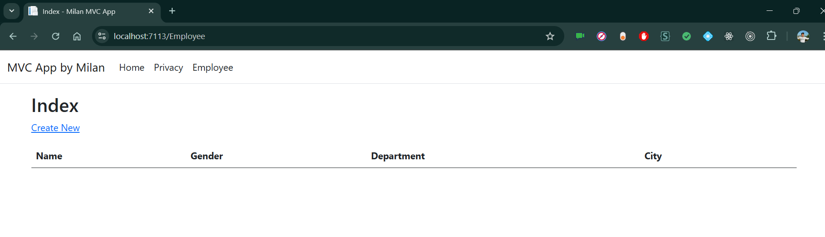

Click on CreateNew to navigate to Create view. Add a new Employee record as shown in the image below.

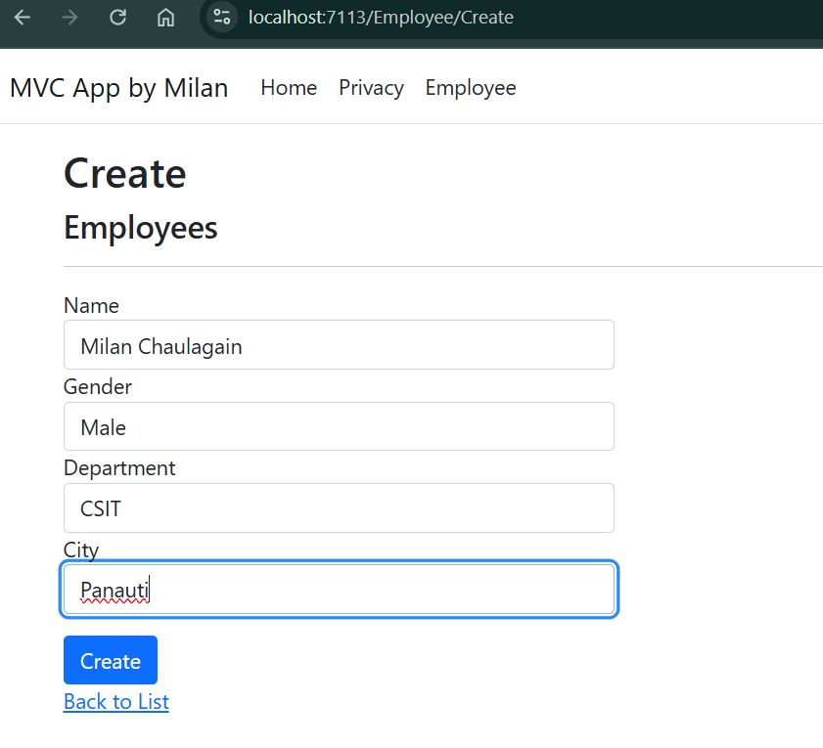

After inserting the data in all the fields, click on “Create” button. The new employee record will be created and you will be redirected to the Index view, displaying records of all the employees. Here, we can also see action methods Edit, Details, and Delete.

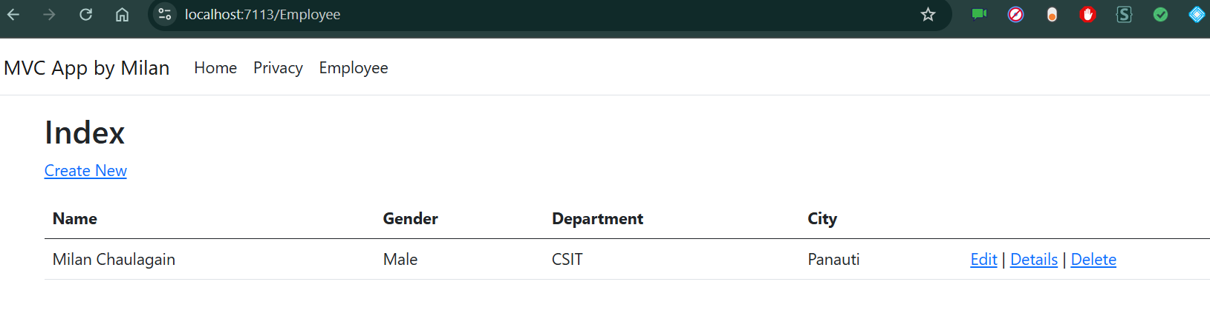

Similarly, Adding some more records.

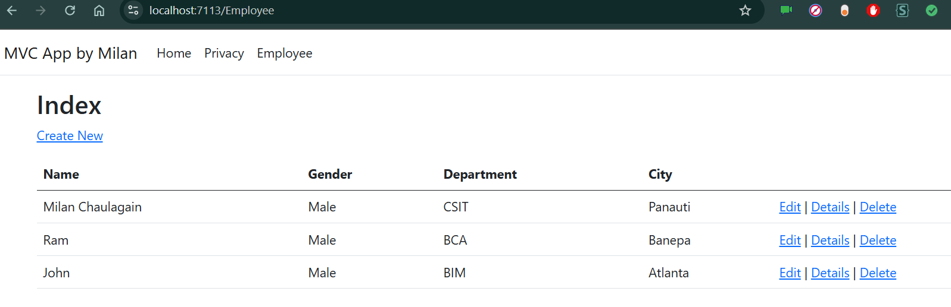

If we want to edit an existing employee record, then click Edit action link. It will open Edit View as below where we can change the employee data.

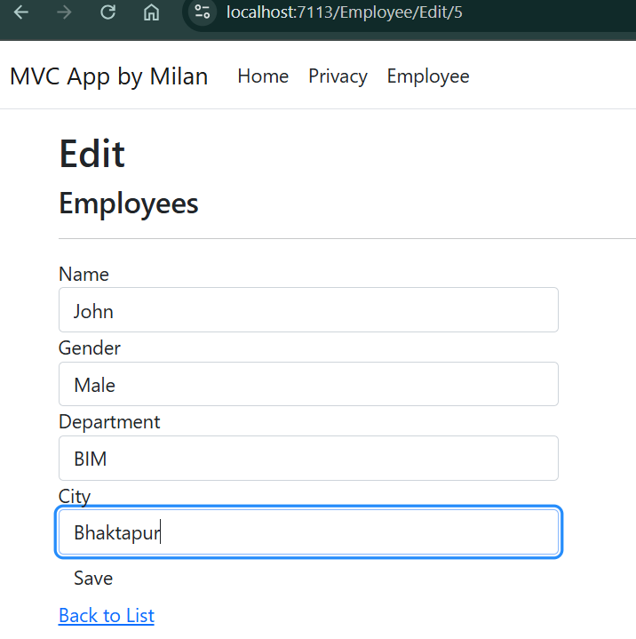

Here we have changed the City of employee John from Atlanta to Bhaktapur. Click on “Save” to return to the Index view to see the updated changes as highlighted in the image below.

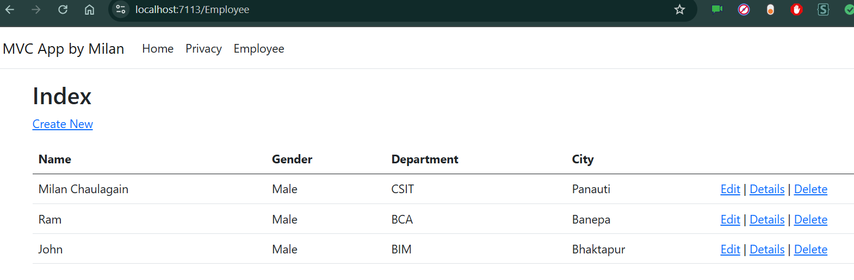

If we miss any fields while editing employee records, then Edit view will also throw required field validation error message

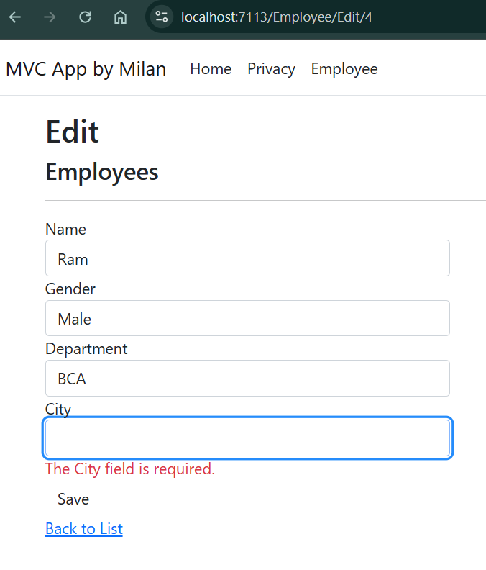

If you want to see the details of any Employee, then click on Details action link, which will open the Details view, as shown in the image below.

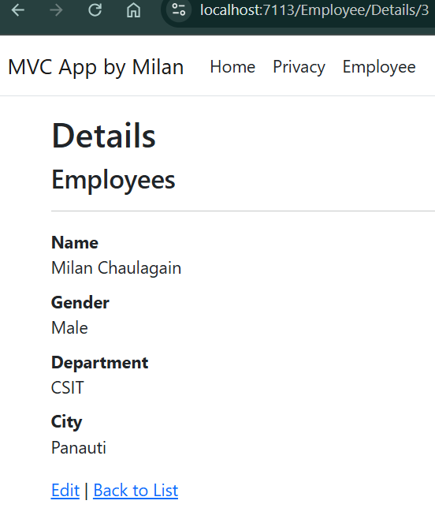

Click on “Back to List” to go back to Index view. Now, we will perform Delete operation on an employee named Venkat. Click on Delete action link which will open Delete view asking for a confirmation to delete.

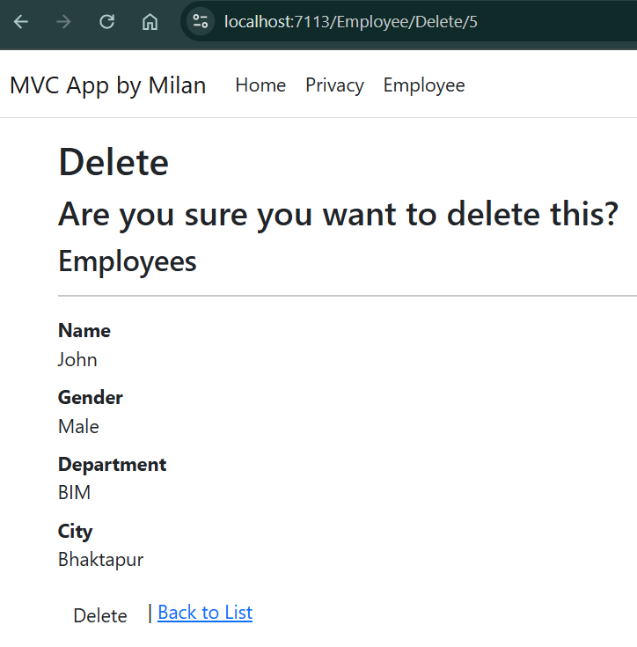

Once we click on Delete button, it will send HttpPost request to delete employee record and we will be redirected to the Index view. Here, we can see that the employee with name Venkat has been removed from our record.

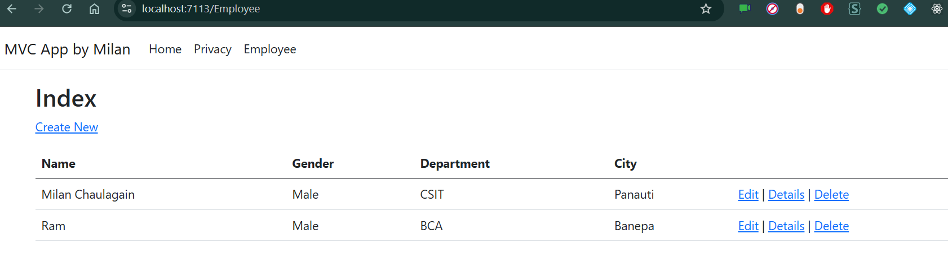

## Conclusion